# INTERNET RADIO:MULTICASTING MULTIMEDIA OVER IP

## A PROJECT REPORT

*Submitted by*

**Sameer Singh [RA2111003010750]**

**Ansh Singh [RA2111003010749]**

**Anik Chaudhary [RA2111003010753]**

**Biplab Nandi [RA2111003010754]**

**Abhishek Gajula [RA2111003010756]**

**Dr. M. Baskar**

Associate Professor, Department of Computer Networks and Security

*in partial fulfillment of the requirements for the degree of*

**BACHELOR OF TECHNOLOGY**

# in

**COMPUTER SCIENCE AND ENGINEERING**



**DEPARTMENT OF DATA SCIENCE AND BUSINESS SYSTEMS**

# COLLEGE OF ENGINEERING AND TECHNOLOGY SRM INSTITUTE OF SCIENCE AND TECHNOLOGY KATTANKULATHUR – 603 203 DEC2023

### LogoSRM INSTITUTE OF SCIENCE AND TECHNOLOGY KATTANKULATHUR – 603 203

**BONAFIDE CERTIFICATE**

Certified that this B.Tech project report titled “**INTERNET RADIO:MULTICASTING MULTIMEDIA OVER IP**” is the bonafide work of Sameer singh [Reg. No.: RA2111003010750],Ansh Singh [Reg. No. RA2111003010749],Anik Chaudhary[Reg No.: RA2111003010753], Biplab Nandi[Reg No.: RA2111003010754], Abhishek Gajula[Reg No.: RA2111003010756] who carried out the project work under my supervision. Certified further, that to the best of my knowledge the work reported herein does not form part of any other thesis or dissertation on the basis of which a degree or award was conferred on an earlier occasion for this or any other candidate.

### DR.M.BASKAR

### FACULTY IN-CHARGE

Associate Professor

Department of Networking and Security

### Dr. ANNAPURANI PANAIYAPPAN.K

**HEAD OF THE DEPARTMENT**

Department of Networking and Security

### SIGNATURE OF INTERNAL EXAMINER

**SIGNATURE OF EXTERNAL EXAMINER**



Department of Data Science and Business Systems

# SRM Institute of Science and Technology Own Work Declaration Form

**Degree/ Course :** B.Tech in Computer Science and Engineering

**Student Names :** Sameer Singh, Ansh Singh, Anik Chaudhary, Biplab Nandi,

Abhishek Gajula

**Registration Number:** RA2111003010750, RA2111003010749, RA2111003010753,

RA2111003010754, RA2111003010756

**Title of Work :** INTERNET RADIO:MULTICASTING MULTIMEDIA OVER IP

We hereby certify that this assessment compiles with the University’s Rules and Regulations relating to Academic misconduct and plagiarism, as listed in the University Website, Regulations, and the Education Committee guidelines.

We confirm that all the work contained in this assessment is our own except where indicated, and that we have met the following conditions:

* Clearly references / listed all sources as appropriate
* Referenced and put in inverted commas all quoted text (from books, web, etc.)
* Given the sources of all pictures, data etc. that are not my own
* Not made any use of the report(s) or essay(s) of any other student(s) either past or present
* Acknowledged in appropriate places any help that I have received from others (e.g. fellow students, technicians, statisticians, external sources)
* Compiled with any other plagiarism criteria specified in the Course handbook / University website

I understand that any false claim for this work will be penalized in accordance with the University policies and regulations.

|  |
| --- |
| **DECLARATION:** |
| I am aware of and understand the University’s policy on Academic misconduct and plagiarism and I certify that this assessment is my / our own work, except where indicated by referring, and that I have followed the good academic practices noted above. |
| If you are working in a group, please write your registration numbers and sign with the date  for every student in your group. |

# ACKNOWLEDGEMENT

We express our humble gratitude to **Dr. C. Muthamizhchelvan**, Vice-Chancellor, SRM Institute of Science and Technology, for the facilities extended for the project work and his continued support.

We extend our sincere thanks to Dean-CET, SRM Institute of Science and Technology, **Dr. T.V.Gopal**, for his invaluable support.

We wish to thank **Dr. Revathi Venkataraman**, Professor & Chairperson, School of Computing, SRM Institute of Science and Technology, for her support throughout the project work.

We are incredibly grateful to our Head of the Department, **Dr. M. Lakshmi,** Professor, Department of Data Science and Business Systems, SRM Institute of Science and Technology, for her suggestions and encouragement at all the stages of the project work.

We want to convey our thanks to our Project Coordinator, **Dr. P. Rajasekar**, Assistant Professor, Panel Head, **Dr. A. Murugan**, Associate Professor and members, **Dr. R. Rajkumar,** Assistant Professor, **Dr. T. Karthick,** Assistant Professor and **Dr. S. Jeeva,** Assistant Professor, Department of Data Science and Business Systems, SRM Institute of Science and Technology, for their inputs during the project reviews and support.

We register our immeasurable thanks to our Faculty Advisor, **Dr. K. Priyadarsini**, Assistant Professor, Department of Data Science and Business Systems, SRM Institute of Science and Technology, for leading and helping us to complete our course.

Our inexpressible respect and thanks to our guide, **Dr. A. Murugan**, Associate Professor, Department of Data Science and Business Systems, SRM Institute of Science and Technology, for providing us with an opportunity to pursue our project under his mentorship. He provided us with the freedom and support to explore the research topics of our interest. His passion for solving problems and making a difference in the world has always been inspiring.

We sincerely thank the Data Science and Business Systems Department staff and students, SRM Institute of Science and Technology, for their help during our project. Finally, we would like to thank parents, family members, and friends for their unconditional love, constant support, and encouragement.

### Sameer Singh [RA2111003010750]

### Ansh Singh [RA2111003010749]

### Anik Chaudhary [RA2111003010753]

### Biplab Nandi [RA2111003010754]

### Abhishek Gajula [RA2111003010756]

# TABLE OF CONTENTS

|  |  |  |
| --- | --- | --- |
| S.NO | NAME | PAGE NO |
| 1 | ABSTRACT | 8 |
| 2 | TABLE FOR IMAGES AND CHART | 9 |
| 3  3.1  3.2 | INTRODUCTION  IDEAD OF FURTHER DEVELOPMENT  IMPLEMENTATION AND DESIGN | 10  10  10 |
| 4 | RECIVER AND SENDER CONNECTION | 11 |
| 5 | SYSTEM DESIGN | 13 |
| 6 | SCREENSHOTS | 17 |
| 7 | CODES | 21 |
| 8 | CONCLUSION | 38 |
| 9 | REFERENCE | 39 |
| 10 | FUTURE SCOPE | 40 |

**ABSTRACT**

# 

The project “Internet Radio: Multicasting Multimedia over IP” explores the fascinating world of IP multicast and the handling of multimedia traffic. Let’s delve into the details with a Project Objective with a primary goal to create an internet TV/radio system using IP multicast. The project leveraged prior experience in sending data over TCP and UDP connections, as well as structured data handling from previous labs. Multicasting Approach is Any Source Multicast (ASM) model which was used for multicasting. The system allowed for efficient distribution of multimedia content to multiple clients simultaneously. Implementation and Design has all the code followed a multiple-process approach (not multi-threading) and the key functionalities included are the Client-Server Communication where Clients connected to the server, received channel information, and selected desired channels. Station Management Clients could pause, reset, change stations, or close the application. Content Handling which is managed which multimedia content efficiently. Potential Applications are Internet Radio, Video Streaming broadcasting. Currently, the code is designed for Linux systems, but with modifications in socket programming, it could be adapted for Windows as well.

|  |  |  |
| --- | --- | --- |
| S.NO | NAME | PAGE NO |
| 1 | TYPES OF CASTING | 10 |
| 2 | PHASE1 | 13 |
| 3 | PHASE 2 | 13 |
| 4 | PHASE 3 | 14 |
| 5 | PHASE 4 | 14 |
| 6 | CHANGE IN STATION | 15 |
| 7 | CLOSE STATION | 13 |
| 8 | SCREEN SHOTS | 17-20 |

# INTERNET RADIO:MULTICASTING MULTIMEDIA OVER IP

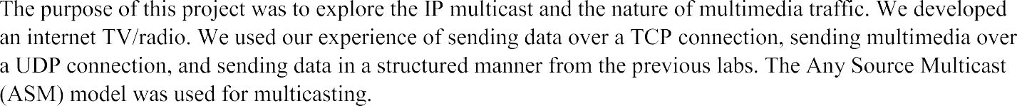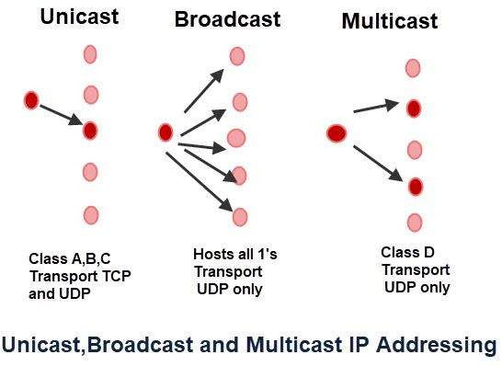





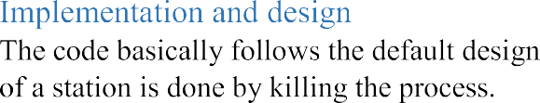

**Receiver and Sender connection implementation through IP**

Setting up a client-server connection through IP (Internet Protocol) involves several steps to establish communication between two devices over a network. Here's an explanation of the process:

1. Device Identification:

Every device on a network has a unique IP address to identify it. The server and client devices must know each other's IP addresses.

2. Network Configuration:

Ensure that both the client and server devices are connected to the same network. This could be a local area network (LAN) or a wide area network (WAN), depending on your setup.

3. Server Configuration:

The server device needs to be running server software that listens for incoming connections. This typically involves specifying a port number for the server application to listen on. The server listens on a specific IP address and port combination.

4. Client Configuration:

The client device needs to run client software that initiates the connection. The client software needs to know the IP address and port number of the server it wants to connect to.

5. Establishing the Connection:

The client sends a connection request to the server's IP address and port number.

The server, which is listening on the specified port, receives the connection request and accepts it.

Once the server accepts the connection, a communication channel is established between the client and server.

6. Data Transfer:

After the connection is established, the client and server can exchange data. The communication can be one-way (client-to-server or server-to-client) or bi-directional, depending on the application.

7. Data Protocol:

Typically, client-server communication uses a specific protocol, such as HTTP for web servers or FTP for file transfers. Both the client and server must follow this protocol to understand each other's requests and responses.

8. Handling Errors and Disconnections:

The client and server need to be prepared to handle errors and disconnections gracefully. This includes error handling, timeouts, and reconnection strategies.

9. Security Considerations:

Depending on the nature of the communication, security measures may be necessary. This can involve using encryption (e.g., HTTPS for web communication) and authentication to protect data and ensure the client is connecting to a trusted server.

In summary, setting up a client-server connection through IP involves configuring both the client and server devices, ensuring they are on the same network, and establishing a connection by specifying the IP address and port number. Once the connection is established, data can be exchanged, typically following a specific protocol, and both sides need to handle potential errors and ensure security measures are in place, if required.

\



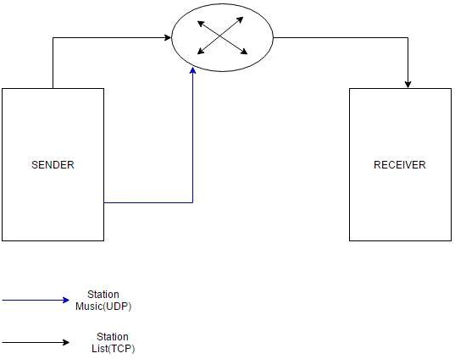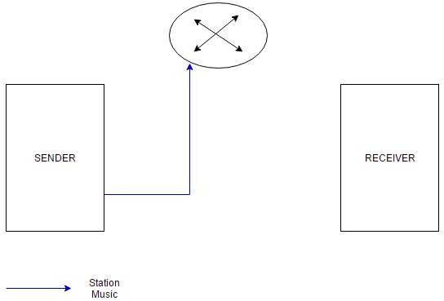



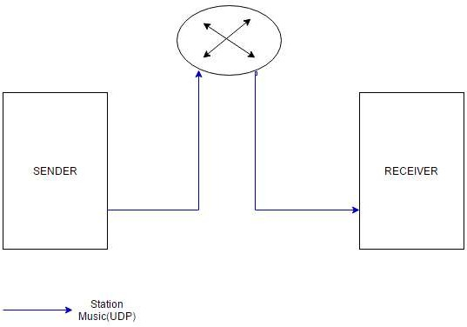









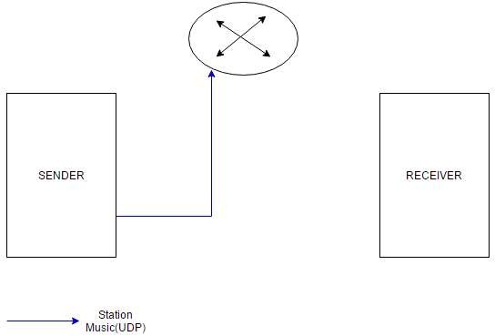





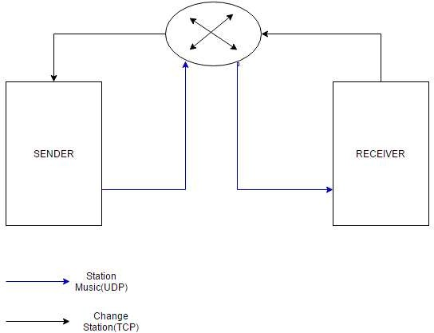





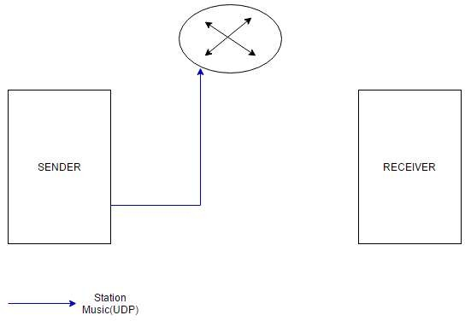



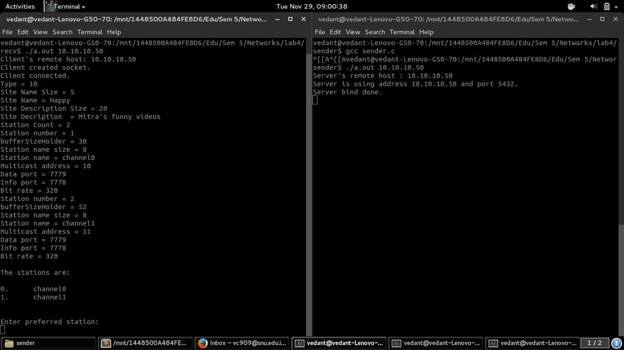

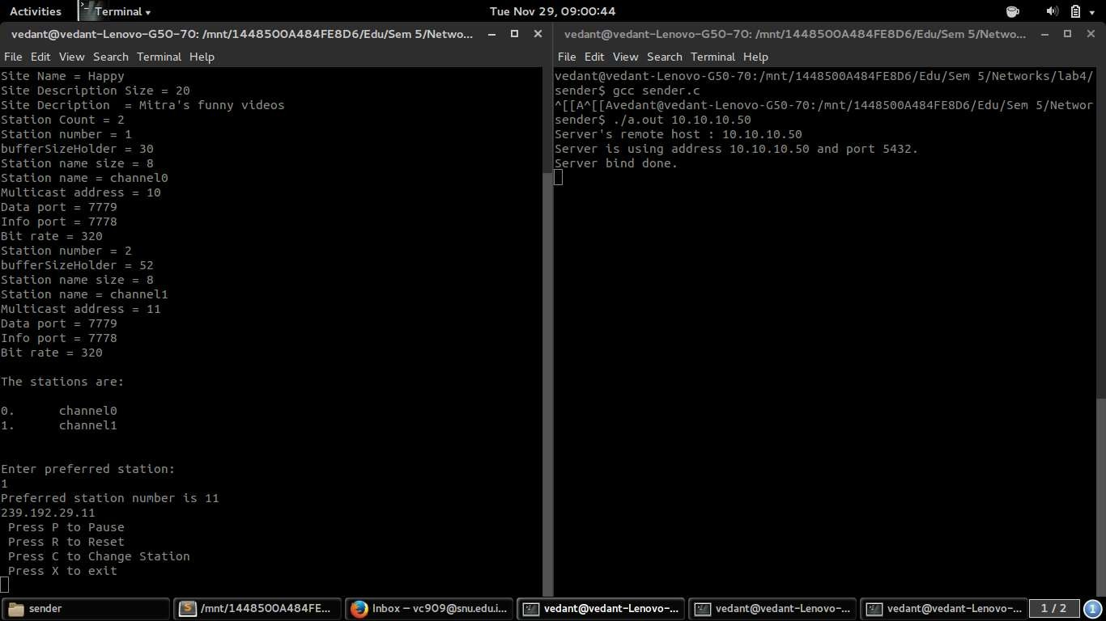

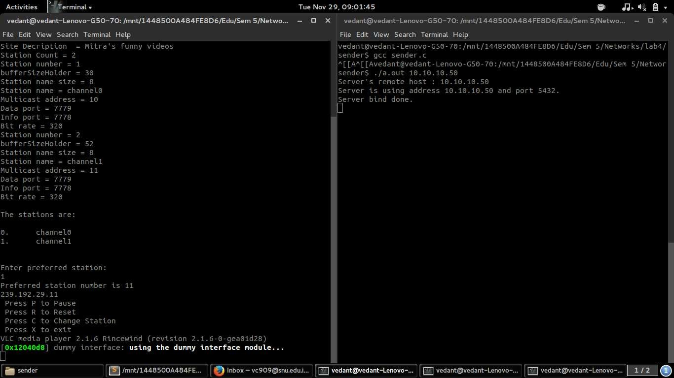

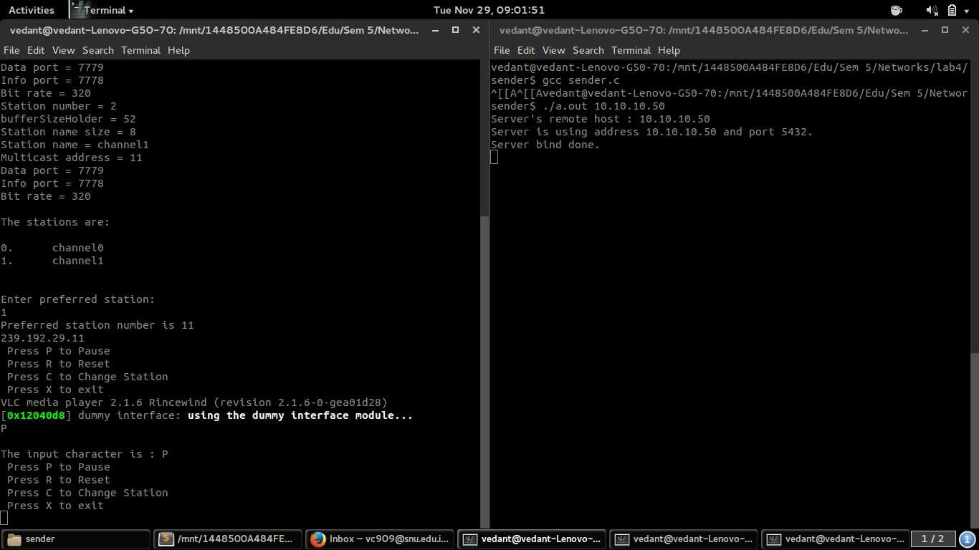

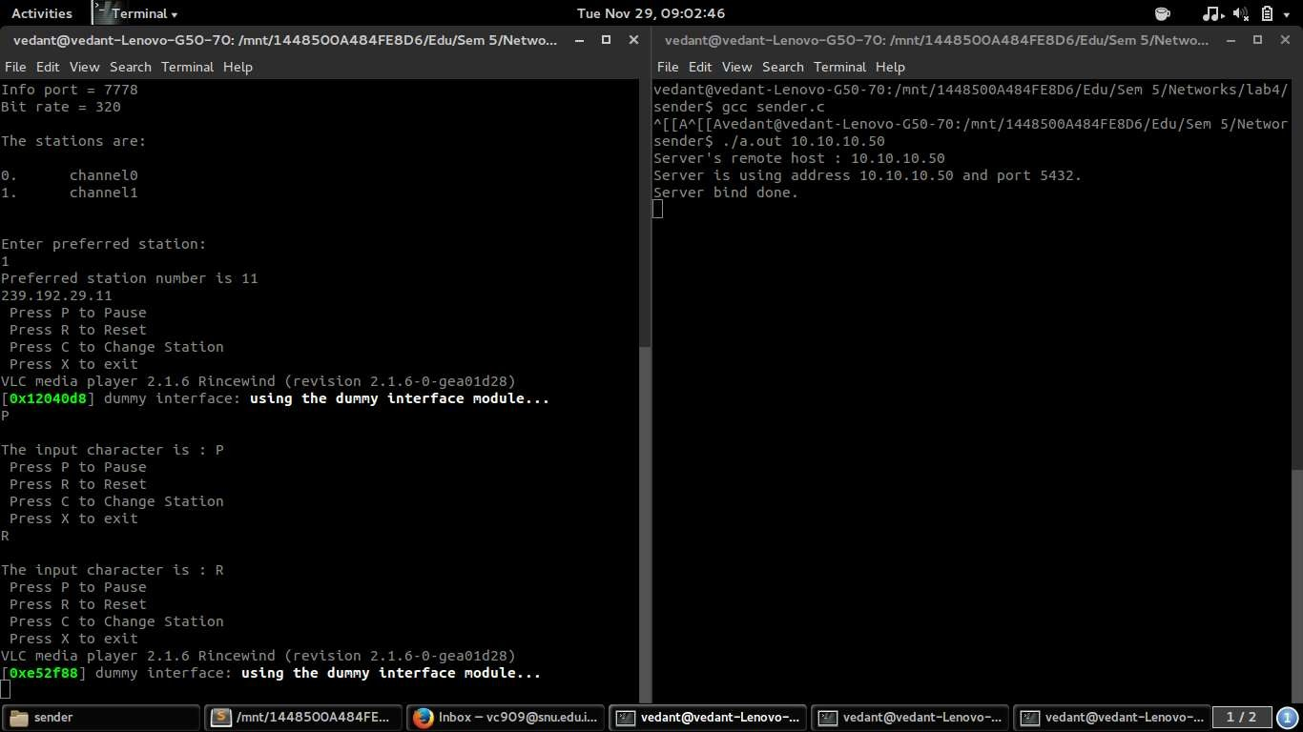

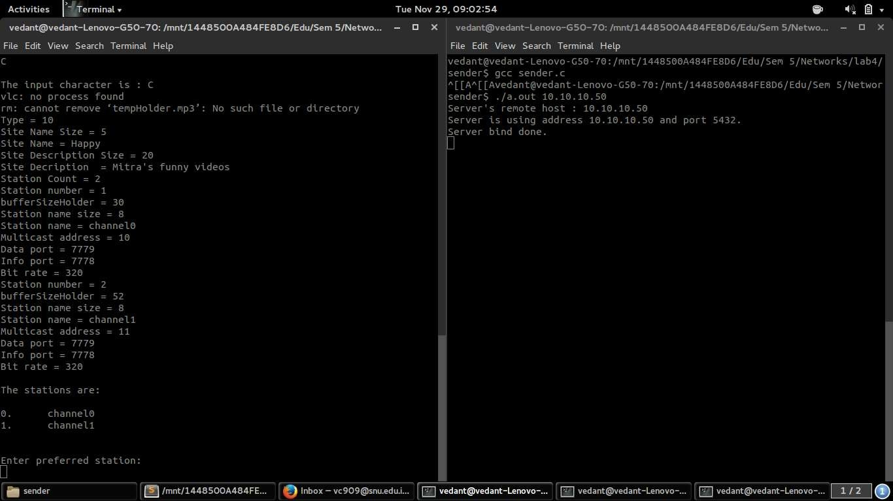

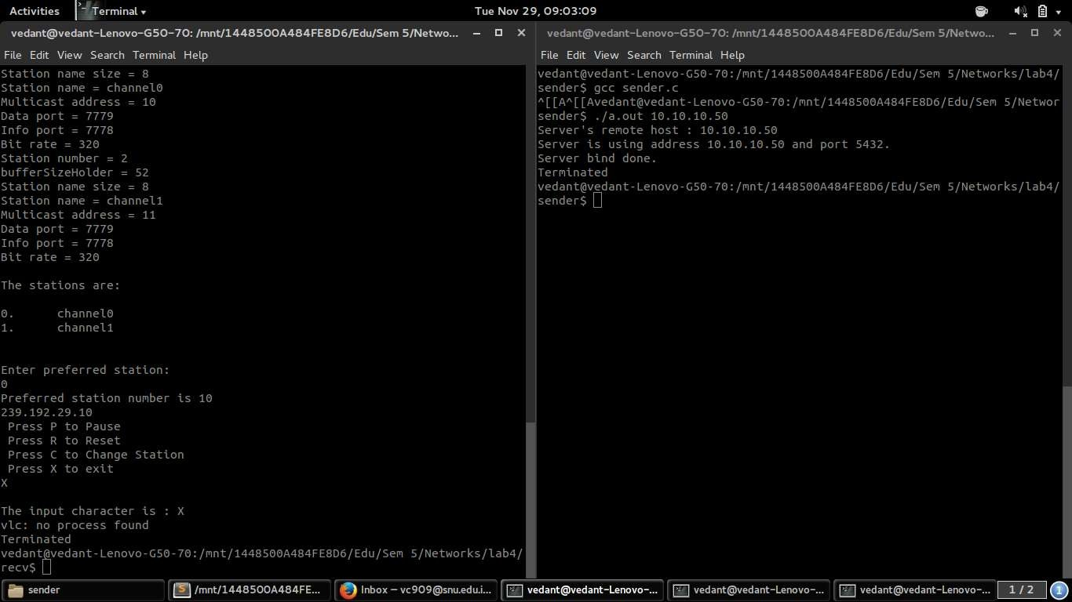



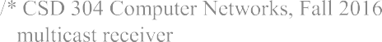



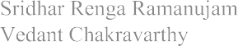







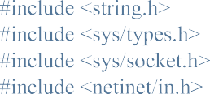





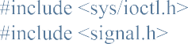

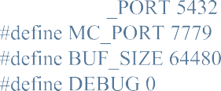



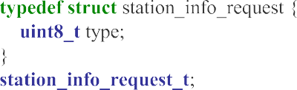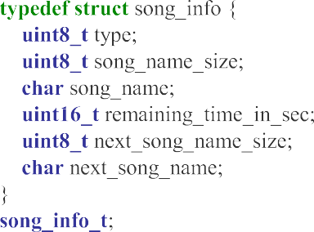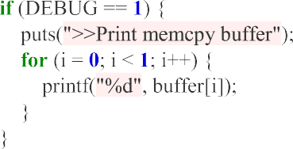

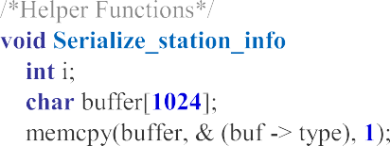

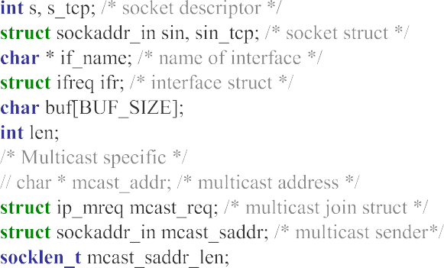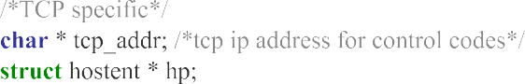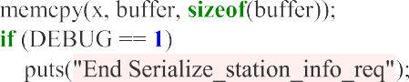

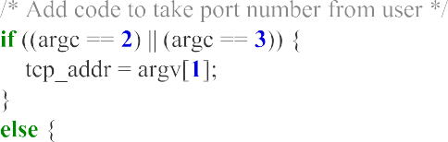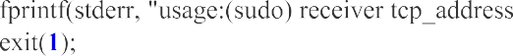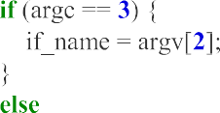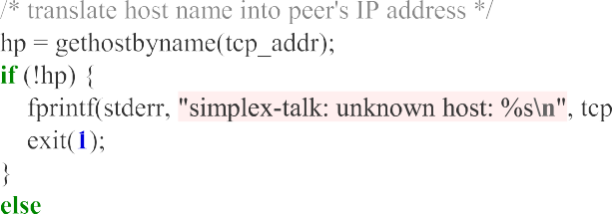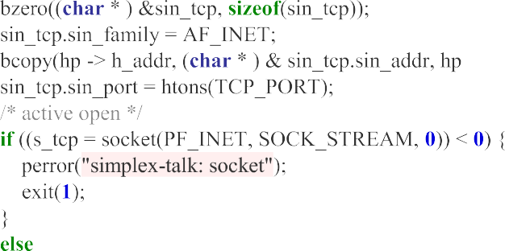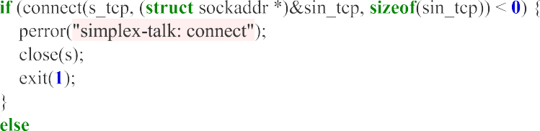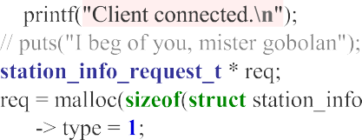

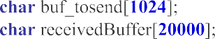

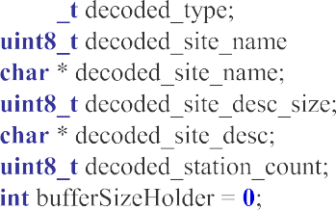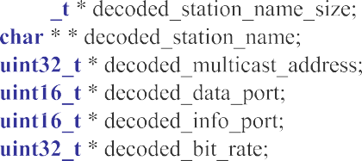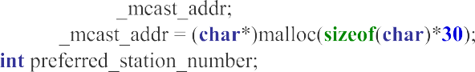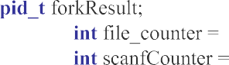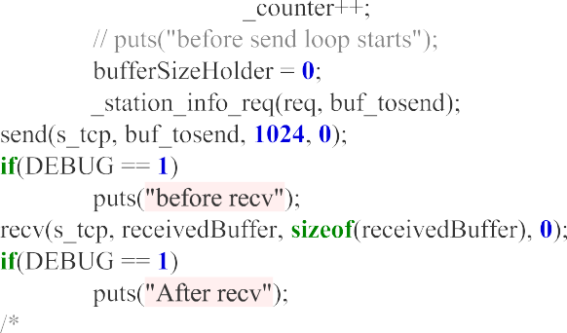

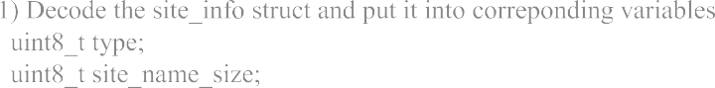

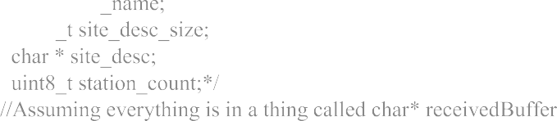

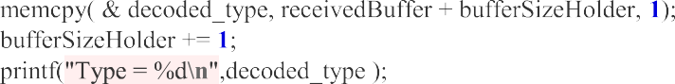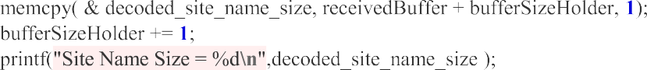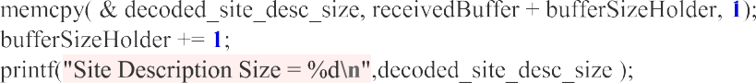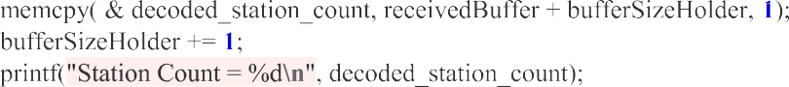

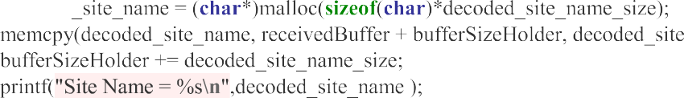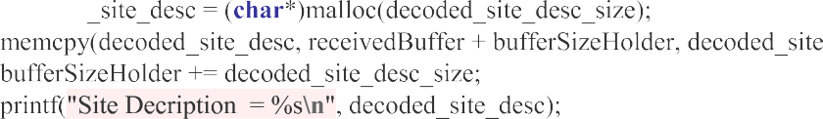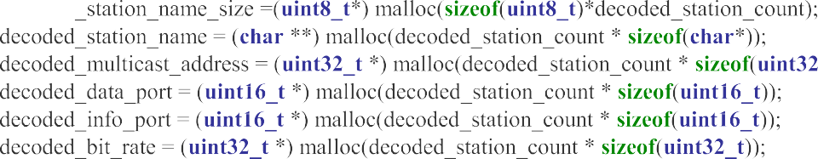

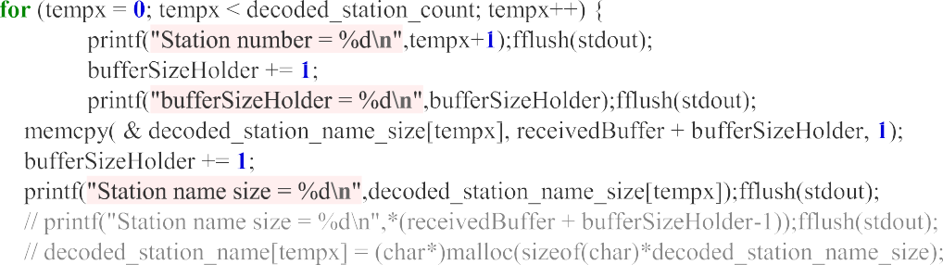

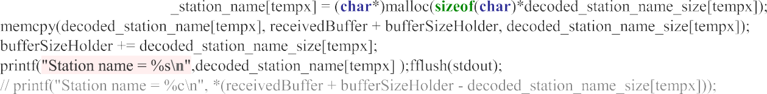





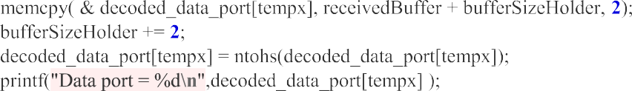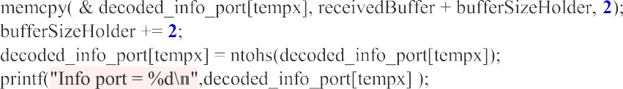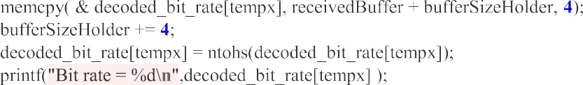

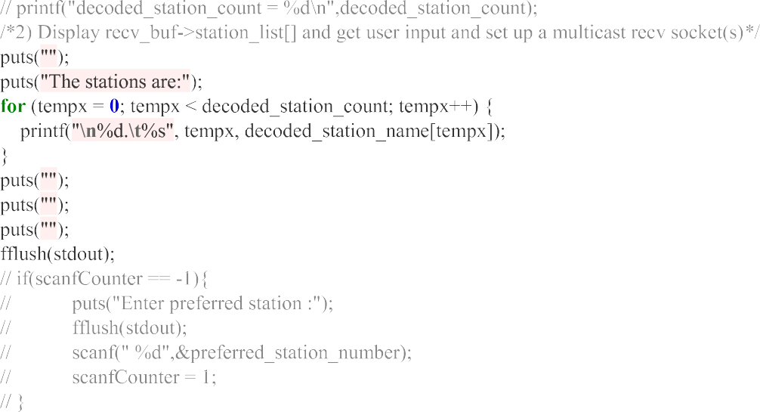

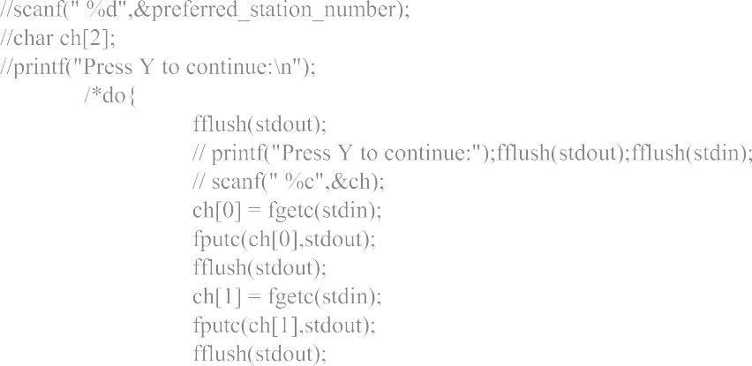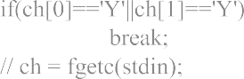

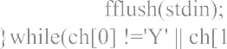

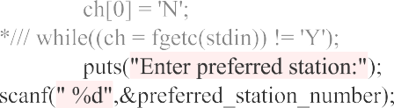

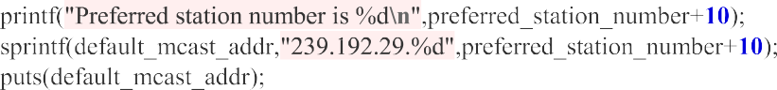



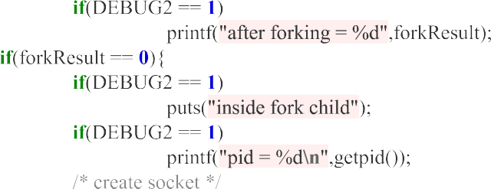

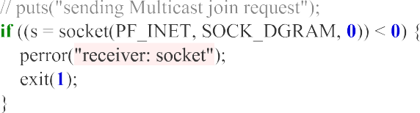



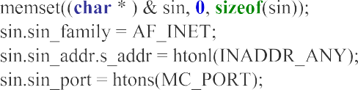

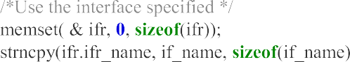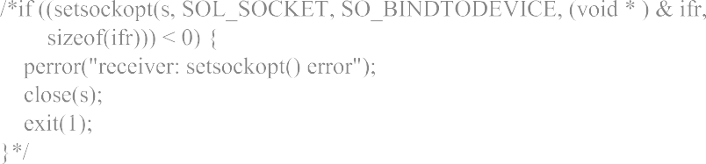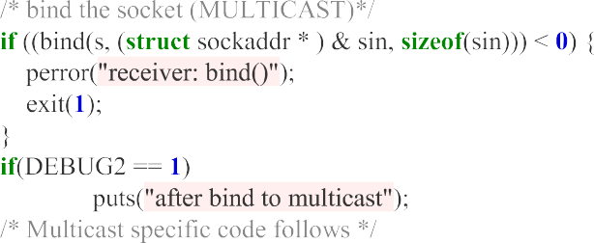

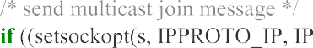

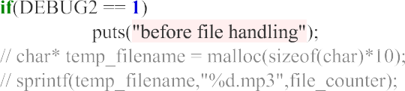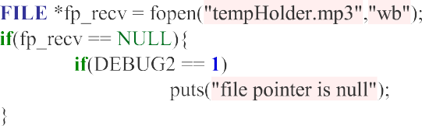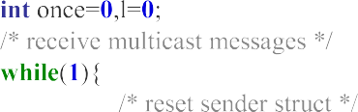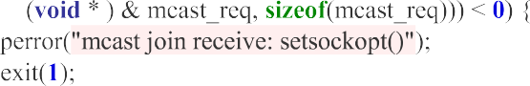

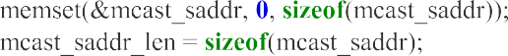



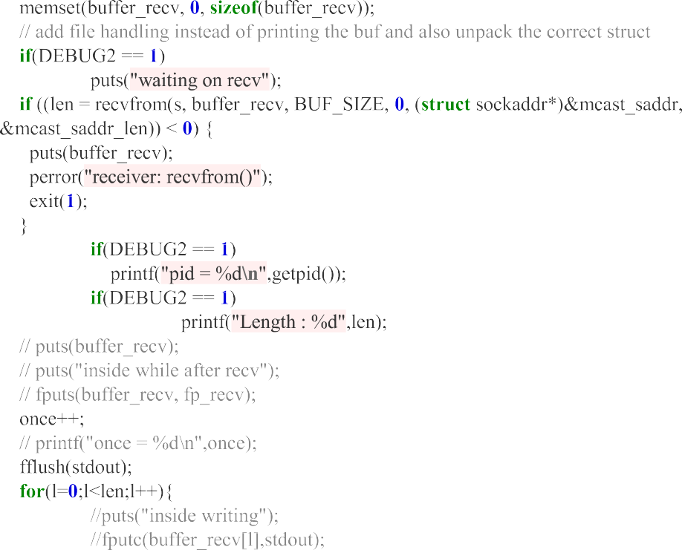







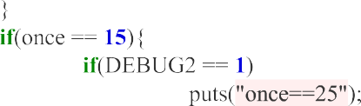

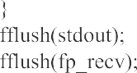



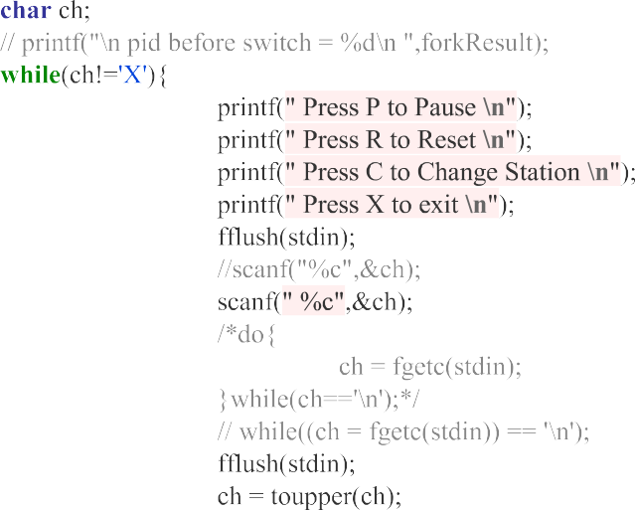

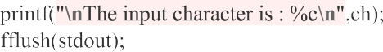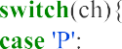

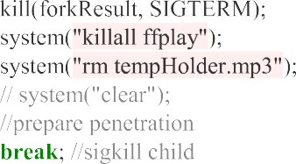



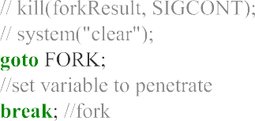



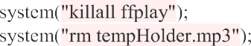

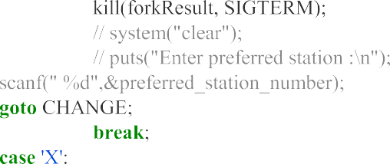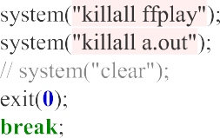



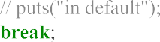

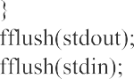





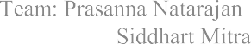

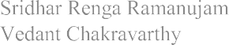







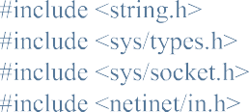





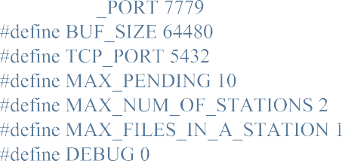





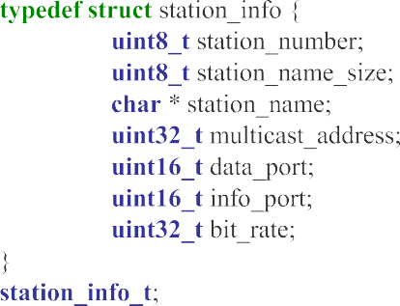



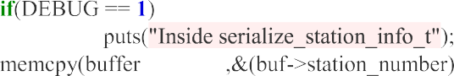  

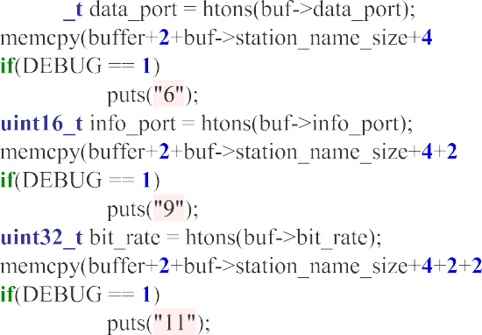

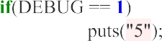



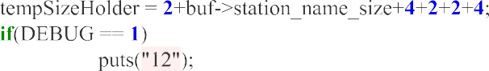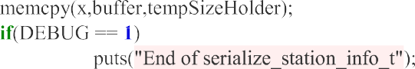

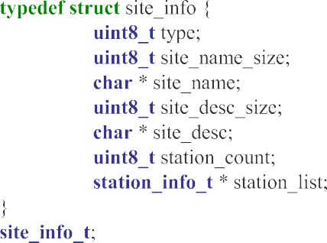









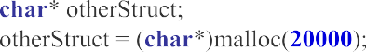

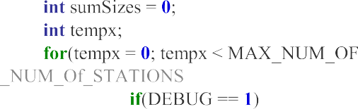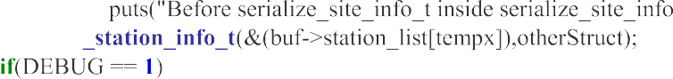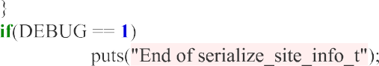



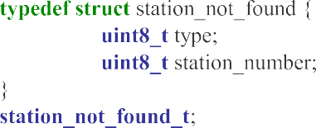





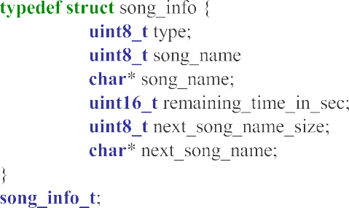

  









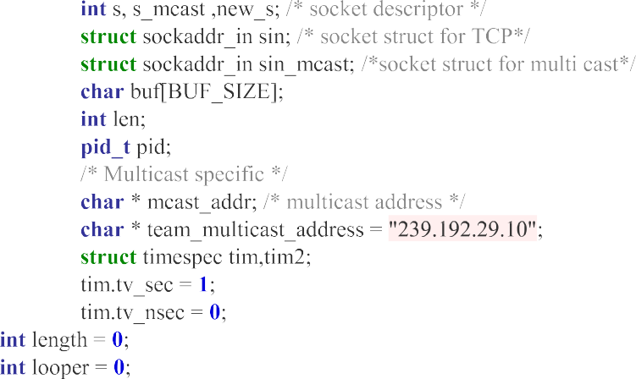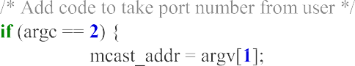



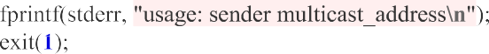

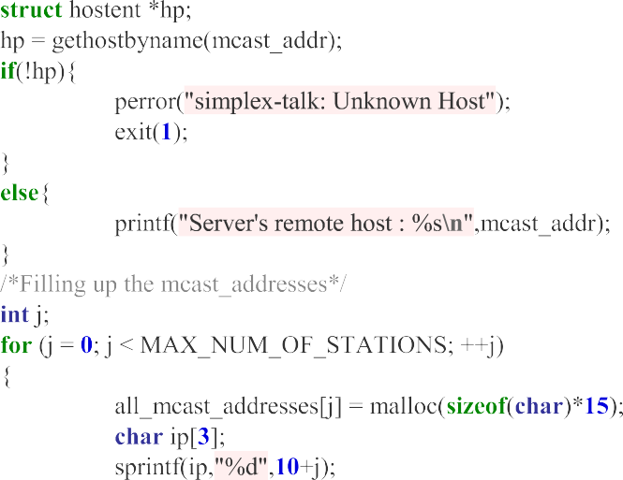

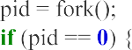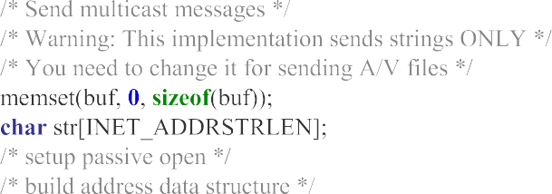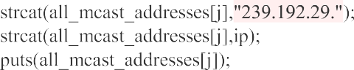

# 

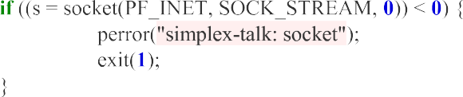





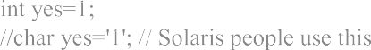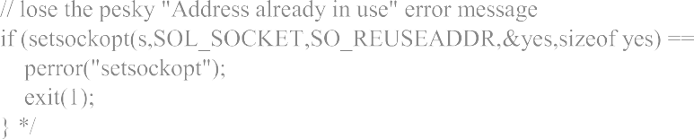

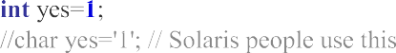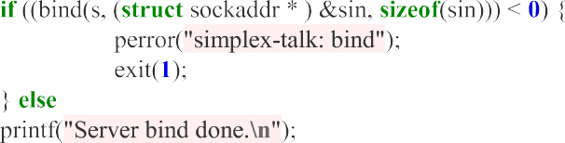

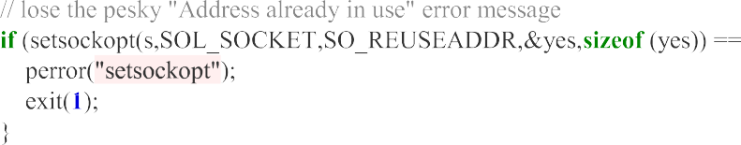





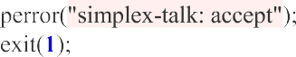





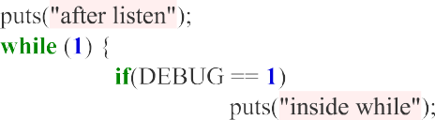



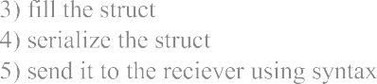





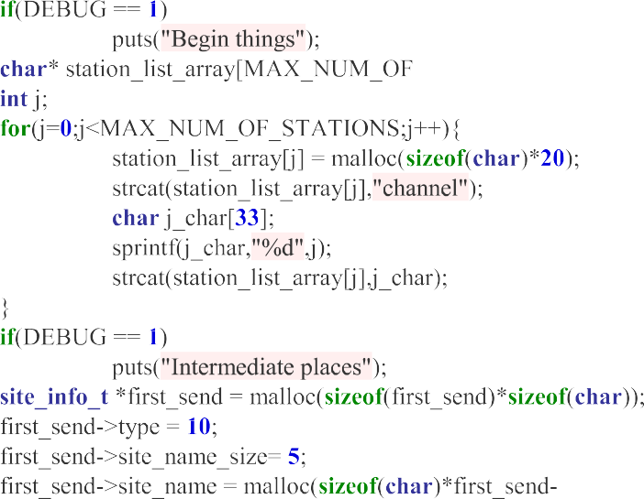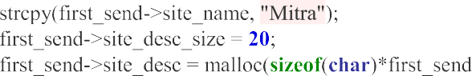



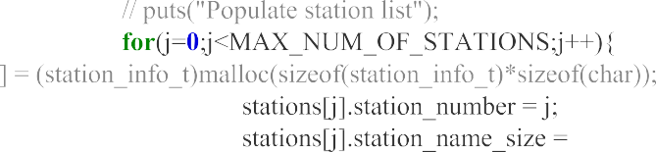









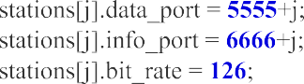

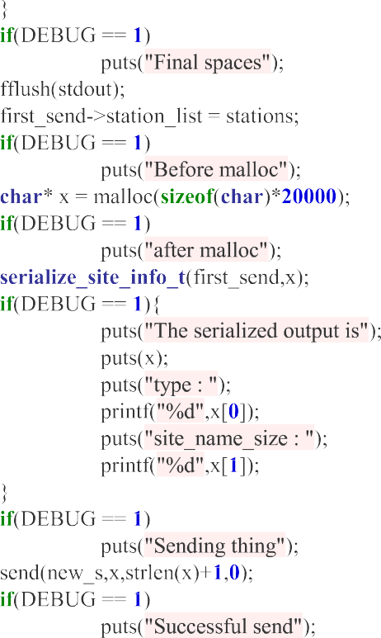



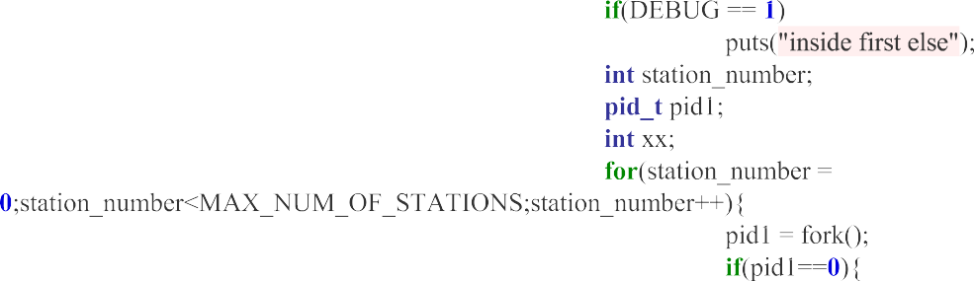

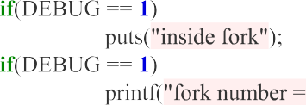









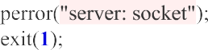



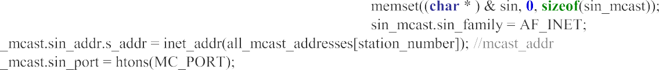





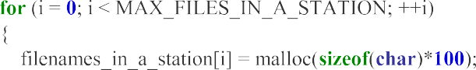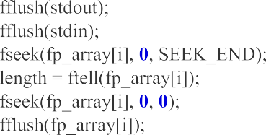

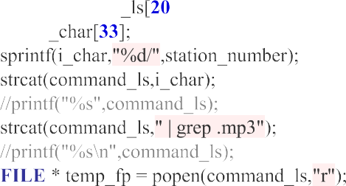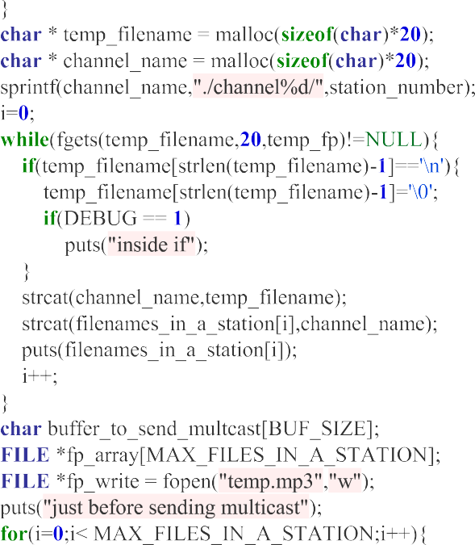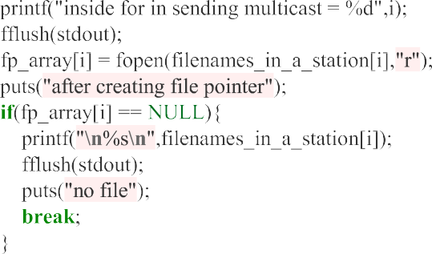

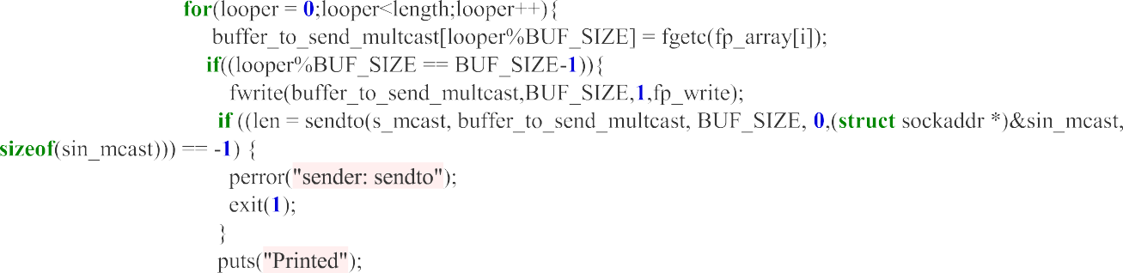

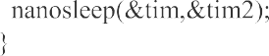

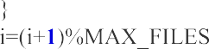

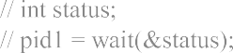



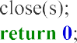

Conclusion

we presented several techniques for multimedia broadcasting over the Internet: IP Unicast, IP Multicast, and the new technique IP Simulcast. In summary, the IP Simulcast protocol is the superior technique for real-time data broadcasting on the Internet. It enables an efficient coverage of “big events” on the Web, without additional investment to the server and network bandwidth. The number of connections on the Internet, covered by IP Simulcast, is practically unlimited. Coupled with efficient audio and video compression techniques, IP Simulcast offers an attractive solution for a number of broadcast applications on the Internet including radio and television broadcast, real-time broadcasting of critical data, distance learning, and many others

REFERENCES

1. C. Semeria and T. Maufer, “Introduction to IP Multicast Routing”, September 1996.http://www.ipmulticast.com/community/semeria.html

2. C. Huitema, “Routing in the Internet”, Prentice Hall, Inc., Englewood Cliffs, New Jersey,1995.

3. “Writing IP Multicast-Enabled Applications”, Stardust Technologies, <http://www.ipmulticast.com/community/whitepapers/ipmcapps.html>

4. W. Bremser, “Pump Up the Volume”, Computerlife, January 1998, pp. 91.

5. M. R. Macedonia and D. P. Brutzman, “MBone Provides Audio and Video Across theInternet”, IEEE Computer, April 1994, pp. 30-36.6. V. Kumar, “MBONE: Interactive Media and the Internet”, New Riden, 1996.

7. V. Johnson and M. Johnson, “How IP Multicast Work”, Stardust Technologies,http://www.ipmulticast.com/community/whitepapers/howipmcworks.html

8. V. Johnson, M. Johnson, and K. Miller, “Implementing IP Multicast in Different NetworkInfrastructures”, Stardust Technologies,http://www.ipmulticast.com/community/whitepapers/netinfra.html

9. J. Ice, “Method for Connecting Systems Into a Broadcast Network”, patent pending.

10. J. Ice and R. Westwater, “System and method for Improved Quality Compression andDecompression of Speech Signals”, patent pendin.

Future Scope:

The **Internet Radio: Multicasting Multimedia over IP** project report [1](https://prasannanatarajan.github.io/project/academic_project_undergrad/Internet_Radio.pdf) explores the use of IP multicast for multimedia traffic. The project developed an internet TV/radio and used experience from previous labs to send data over a TCP connection, send multimedia over a UDP connection, and send data in a structured manner. The Any Source Multicast model was used for multicasting. The report suggests that this project can potentially be used for internet radio and live streaming of videos. Currently, the code is meant only for Linux systems, but modifications in socket programming can make it viable for the Windows platform too .

Another resource that might be of interest is the **Adaptive media streaming over IP multicast Implementation guidelines** . This document defines a functional architecture for delivering live and on-demand adaptive streaming media to a large audience in a highly efficient and scalable way by leveraging IP multicast for media object delivery